**MARS: Mall Augmented Reality Navigation System**

Aubrey V. Mondero John Emmanuel A. Castañeda Mark J. Nieto

College of Computer Studies College of Computer Studies College of Computer Studies

Our Lady of Fatima University Our Lady of Fatima University Our Lady of Fatima University

Valenzuela City, Philippines Valenzuela City, Philippines Valenzuela City, Philippines

[aubreyvmondero@gmail.com](mailto:aubreyvmondero@gmail.com) jacastaneda@student.fatima.edu.ph [mjnieto1@student.fatima.edu.ph](mailto:mjnieto1@student.fatima.edu.ph)

Cloyd Francis G. Jalmasco

College of Computer Studies

Our Lady of Fatima University

Valenzuela City, Philippines

**Abstract— For ages, many people have been seeking something new to enhance the conventional navigation on the mall. Naturally people are using maps to track the places and seek better routes to improve their navigation therefore, We developed MARS (Mall Augmented Reality Navigation System) is an application that benefits Shoppers. They can** **spend less time aimlessly looking for amenities by using indoor navigation and positioning, freeing up more time for dining out or shopping. Customers who use indoor positioning technologies get a distinctive and cutting- edge experience that makes it simple and quick for them to access discounts and find their way around a mall. Beyond the average consumer, indoor navigation and positioning software can help shopping malls. Therefore, researchers aim to develop a mall navigation system based on augmented reality (MARS). It is an android application wherein shoppers can navigate stores inside the mall without being lost and can scan a product so AR Product Information will appear.**

**Keywords—Augmented Reality, Indoor Navigation, Shopping malls, Unity, ARCore, ARfoundation, and Vuforia**

1.0 INTRODUCTION

Nowadays, the use of Google Maps to find the fastest way to access their destination. Navigation systems play a major role in our daily lives. Today's systems use satellite navigation technology to position and show the path to users. They usually provide turn-by-turn navigation instructions and occasional 3D rendering of the path. Augmented Reality has spanned in commercial industries. AR is a 3D rendering of physical objects that are infused in the real world. Chun Lam (2019) stated that indoor positioning technology that combines with augmented reality can make an explicit navigation with real world objects.

According to Bo-Chen Huang et. al. (2020) it can achieve 3 to 5 m accuracy and provide users with correct instructions on their way to destinations. Shoppers can spend less time aimlessly looking for amenities by using indoor navigation and positioning, freeing up more time for dining out or shopping. Customers who use indoor positioning technologies get a distinctive and cutting- edge experience that makes it simple and quick for them to access discounts and find their way around a mall. Beyond the average consumer, indoor navigation and positioning software can help shopping malls. Therefore, researchers aim to develop a mall navigation system based on augmented reality (MARS). It is an android application wherein shoppers can navigate stores inside the mall without being lost and can scan a product so AR Product Information will appear.

1.1 Background of the Study

A cameraman by the name of Morton Heilig initially achieved augmented reality in some capacity in 1957. Morton created the Sensorama, which provided the spectator with sights, sounds, vibrations, and smells. Although it wasn't computer-controlled, it was the first instance of an effort to enrich an experience with additional information. Then, as a form of window into a virtual world, American computer scientist and early Internet influencer Ivan Sutherland created the head-mounted display in 1968. The invention couldn't be employed widely at the time because of the technology available (Juvornick, 2020).

1.2 General Objectives

An augmented reality mall navigation app that helps consumers minimize their time finding the store they want to go. This app can also reduce the risk of human contact because shoppers don’t need to ask strangers about directions. Plus, AR product scanner wherein product description will appear in AR.

1.3 Specific Objectives

This study aims to accomplish the following specific objectives:

MARS aimed to build an indoor mall navigation app based in augmented reality;

Users can navigate all stores inside the mall by the guidance of 2D arrow path

MARS aimed to have an AR Product Scanner wherein the user can scan the product and the AR description will appear.

2.0 DESIGN AND METHODOLOGY

## 2.1 Concept Framework

## 

## 

## 

## 

## 

## Figure 1. This is the input and output process of MARS. Input containing knowledge requirements for implementing this system. Software requirements are the compiler that is used for coding. Hardware requirements are the components used to develop this system. The process proponents used is the SDLC Approach –Agile Model to achieve the final output.

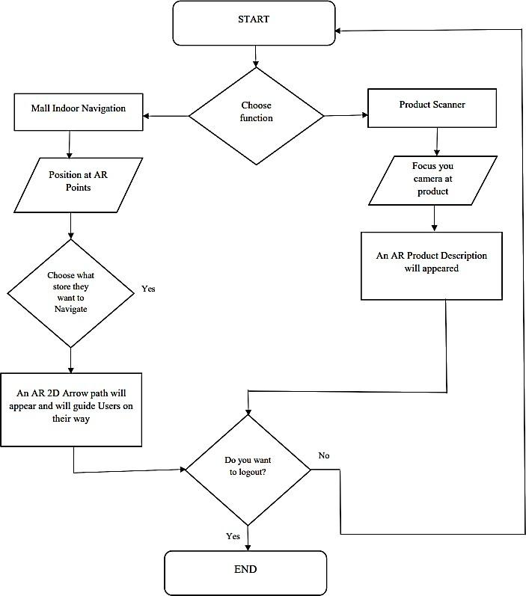

## Figure 2: The first process of the user is to open the application and locate at the designated AR Point to detect the user's location. Choose an option for indoor navigation. After choosing a store, the arrow pathway will guide them. Users can also scan a product and AR description will appear.

## 2.3 Software Development

## 

## 

## 

## 

## 

## Figure 3: The proponents used an agile approach in creating the MARS. The agile shows the step-by-step development of the system.

## 3.0 Result and Discussion

## This discusses the description and structure of the system. The researchers conducted an evaluation and post survey to assess if the proposed system benefitted the shoppers in a certain mall in Valenzuela City. The respondents were composed of Shoppers living in Valenzuela City and IT Experts. The researchers then get the average of the respondents’ response for each question where the computation of mean was applied.

## **Presentation of Data**

*Table 2: Evaluation of all participant*

| **Characteristics** | **Mean Score** | **Interpretation** |
| --- | --- | --- |
| Functionality Suitability | 4.8 | Highly Acceptable |
| Performance Efficiency | 4.7 | Performance Efficiency |
| Usability | 4.7 | Highly Acceptable |
| Reliability | 4.7 | Highly Acceptable |
| Security | 4.6 | Highly Acceptable |
| Maintainability | 4.6 | Highly Acceptable |
| Portability | 4.6 | Highly Acceptable |
| **Overall Weighted Mean 4.7** Highly Acceptable | | |

*4.5* – 5.00 Highly Acceptable, 3.5– 4.5 Very Acceptable, 2.5 – 3.5 Acceptable, 1.5 – 2.5 Moderately Acceptable, 1.00 – 1.49 Unacceptable.

The system "MARS: Mall Augmented Reality Navigation" was evaluated by 20 shoppers and 5 IT Experts by a total of 25 respondents. The system presentation was included in the google form so that the respondents may know about the system's functionalities and how to use it. A questionnaire was provided to each of the respondents to evaluate and rate the system. The proponents used the Weighted Arithmetic Mean Formula to accurately estimate the evaluation's overall results.

4.0 SUMMARY, CONCLUSION AND RECOMMENDATION

4.1 Summary

GPS has a significant influence on how we travel outdoors, but indoors it is useless because the weak signals inside the mall give the receiver no chance of picking up any GPS. Hence there’s still a difficulty in navigating indoor places like shopping malls. As an IT student, the researchers decided to develop a mobile application entitled “MARS augmented reality mall navigation system” that can help shoppers minimize their time finding the store they wanted to go. This app can also reduce the risk of human contact because shoppers don’t need to ask strangers about directions. To make the app more useful, researchers add a feature of AR product scanner wherein product description will appear in AR. This app will benefit shoppers and shopping malls because the customers can easily navigate the store inside the mall without being lost and tired strolling around.

MARS was made in unity with the libraries of ARcore and ARfoundation wherein it supported android phones however ARcore was a new release AR technology so there’s still a phone compatibility issue. Agile approach was used in the process of creating this project and other diagrams in the methodology section were addressed. Implementation and Testing occurred at Valenzuela Town Center. The researchers gather 15 end-users and 5 IT experts in assessing the application and answering the given evaluation form. All the procedures are documented and addressed.

Moreover, the system's evaluation approach was based on the ISO 25010 product quality model. MARS yielded a great outcome, with an average rating of 4.67, which was interpreted as Highly Acceptable. Functionality received the highest mean score of 4.8, then Performance Efficiency with a total mean score of 4.7, Usability with a mean of 4.65, Reliability with a total mean score of 4.7, followed by Portability, Maintainability and Security with a score of 4.6.

4.2 Conclusions

The researchers conclude that MARS: Mall Augmented Reality Navigation System can be used in navigating indoor establishments like shopping malls. It can also scan a specific product inside a mall and then AR product information will appear. By using MARS mobile app, it lessens their time finding the store they wanted to go to. This app also helped the users reduce human contact because they don’t need to ask directions to strangers. The system performed very well in terms of navigating indoor and scanning a product in Valenzuela Town Center. The data that has been collected indicated that the system was highly accepted with the overall result of ISO product quality.

Furthermore, the study addressed the problem and accomplished the general and specific objectives of the study. Unfortunately, the 3D alien companion was unable to add in the features because the compatible phone used in this research was incapable to handle the frame rate per seconds of the 3D companion therefore the application keeps crashing. To avoid the crashing issue, the researchers decided to eliminate the 3D companion and remain the 2D arrow path to help the user navigate the way to their destination. Nevertheless, according to the user assessment’s, the 2D arrow path was very helpful in navigating stores easily. It shows that MARS can truly help shoppers enjoy their shopping spree smoothly without being lost and selected products inside the mall can be scanned using MARS wherein AR information will appear.

## 4.3 Recommendations

## The proponents recommend that the Valenzuela Town Center implement the system. Furthermore, Proponents intend to improve the accuracy of user location indoors, future researchers can use beacons, ARkit, or other efficient indoor navigation technology to detect the accurate location of the user inside the mall or establishment. Future researchers can also make the user interface more interactive and user friendly, for example the stores logo or store location can be clicked in view full map feature. Lastly, adding the 3D companion with an automated voice makes the application more useful and entertaining to us